TMT/+91 91300 63695 /S0495/2025 12 -10-2025

To,
91300 63695

Dear Sirs,

Sub: - Supply of Three Roller Plate bending machine with Pre-Pinching.

We thank you for your enquiry regarding Plate Bending machine for MS plate width 2000 thickness of 16 mm. We are glad to inform you that we would be in a position to do the required equipment with the following specifications and description of the machine along with our terms and conditions.

Specifications of the equipment :

1) Maximum width of Rolling : 2000 MM

2) Maximum thickness of Rolling : 16 MM

2a) pre pinching capacity : upto 16 mm for MS
Upto 12 mm for SS

3) Top Roll diameter : 280 MM

4) Bottom Roller Diameter : 265 MM

5) Minimum Rolling Diameter : 490 MM

6) Rolling speed : 3.0 rpm.

7) Maximum yield limit of the plate : 245 Mpa.

8) Total power : 23.5 HP

9) Cone bending can be done up to 16 mm thickness and width 2000 mm only

Main drive : 10 HP
Screw drive: 5 HP - 2 nos
Door opening : 3 HP
Oil pump :.5 HP

S No | Description of the unit | Offer
1. | Plate bending machine for 2000x16 mm with 10 HP main drive 5 HP-2 load drives along with complete electricals. | Rs 28,00,000/- (Rupees Twenty Lakhs only)

GENERAL TERMS & CONDITIONS:

- Price quoted per unit ex-work. Hyderabad.
- Following charges are additional to your account.
- Freight Charge : As actual to be borne by you.
- Excise : Extra As Applicable
- Sales Tax : Extra as applicable
- Packing charge : As actual to be borne by you.
- Insurance : As actual to be borne by you.
- Payment& Delivery : 50% advance delivery within one 45 days.
- Validity : One month from the date of submission.
- Inspection : Inspection at our works prior to dispatch.
- Warranty : The machine is warranted for a period of 12 months from the date of dispatch against any manufacturing defects/ faulty material or bad workmanship of any part or component but not against any kind of abnormal or improper use of machine. Defective part or component will be replaced or repaired free of cost. Electrical components are outside the scope of this warranty.
- Commissioning : Erection & commissioning done by you, but required technical support & guidance provide by us at additional cost.

NOTE:
- Oil is not in our scope of supply.
- Raw material for trial is to be arranged by you at your cost.

We are sure you will find our offer in line with your requirements. Should you require any further clarification please contact 9246221106/9849207176 email: srktalam@gmail.com

Thanking you and assuring you of our best services.

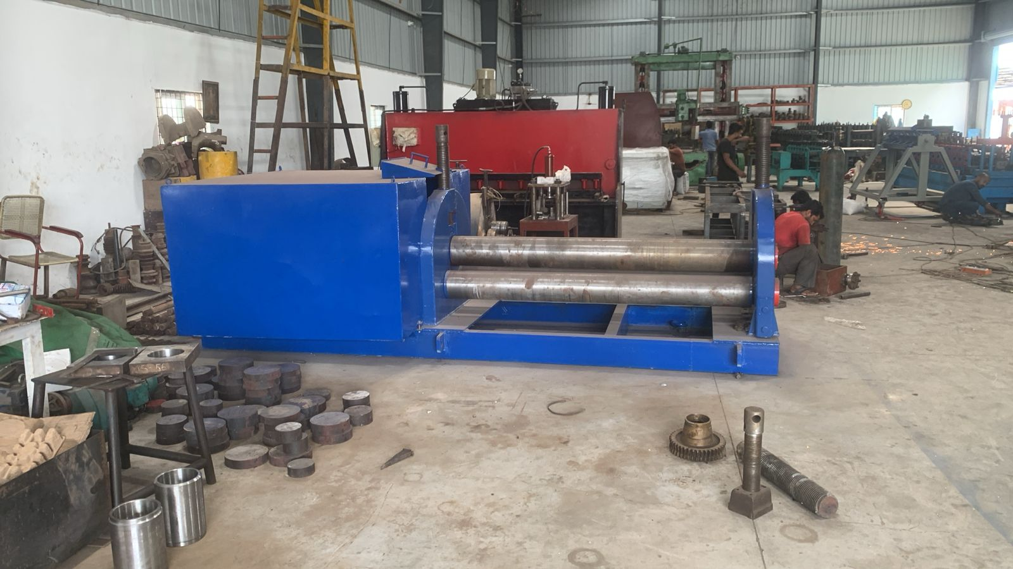

For TECHNO MACHINE TOOLS

( T. SIVARAMAKRISHNA)

